**CIS 581: Computer Vision**

**Project 4 Part A**

**Image Carving and Image Blending**

**Name: Jae Joon Lee, Vivek Raj**

**Task 1: Image Carving and Resizing**

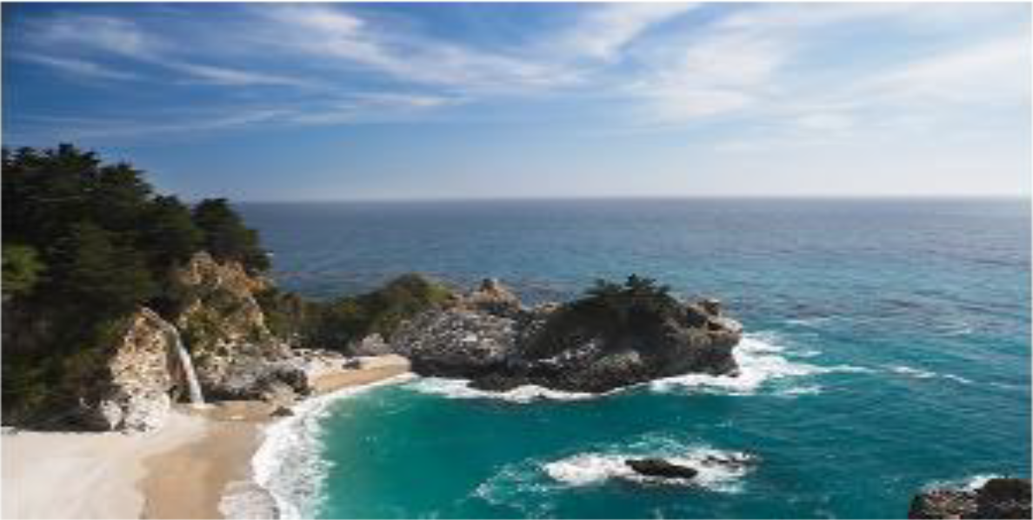

**Figure 1: Original image (598 x 1188)**

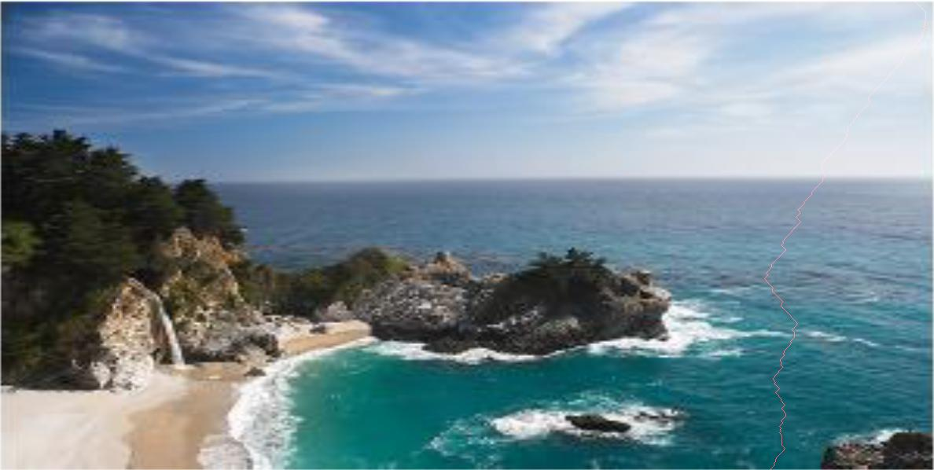

**Figure 2: Original image with one vertical seam drawn (598 x 1188)**

**\* Vertical seam pixels were given Red value of 255 for visibility. (same for horizontal below)**

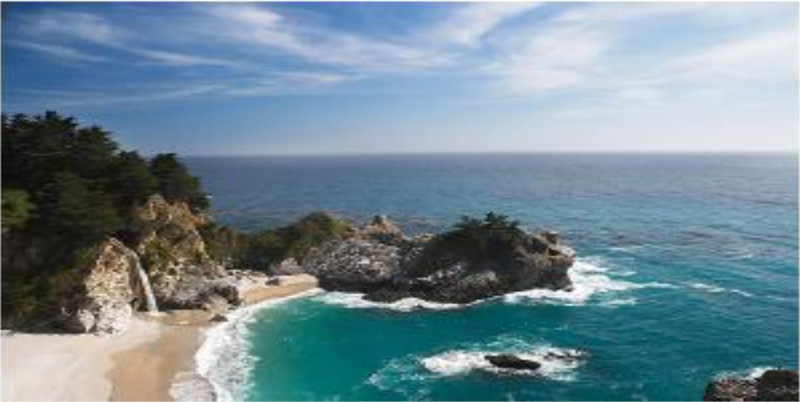

**Figure 3: One vertical seam removed (598 x 1187)**

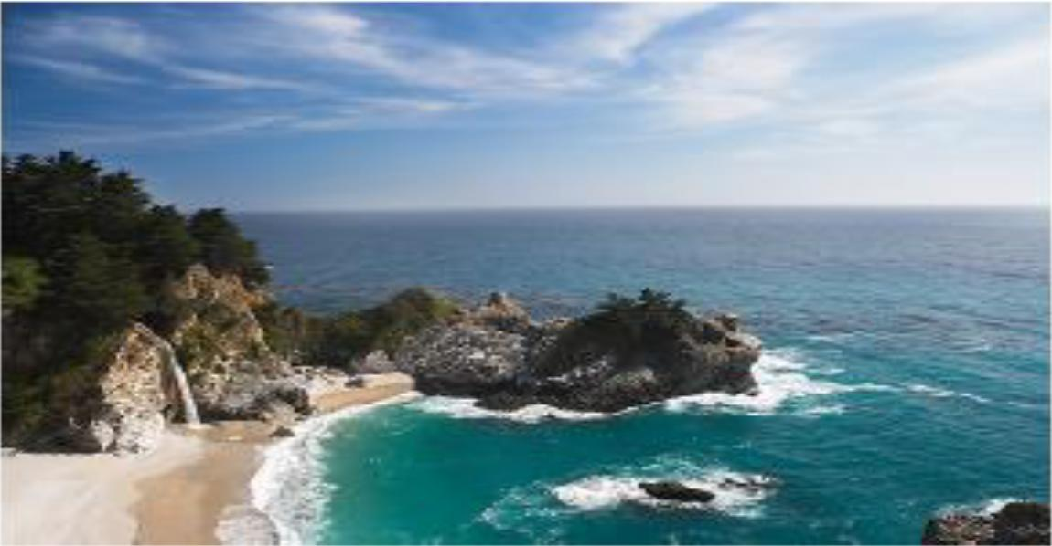

**Figure 4: 38 vertical seams removed (598 x 1150)**

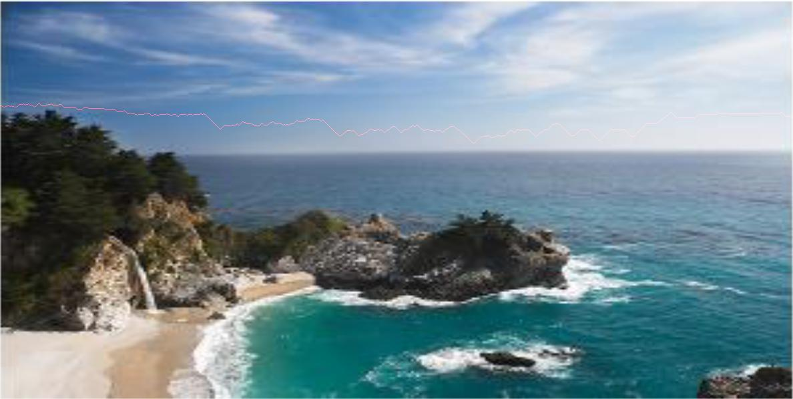

**Figure 5: Original image with one horizontal seam drawn (598 x 1188)**

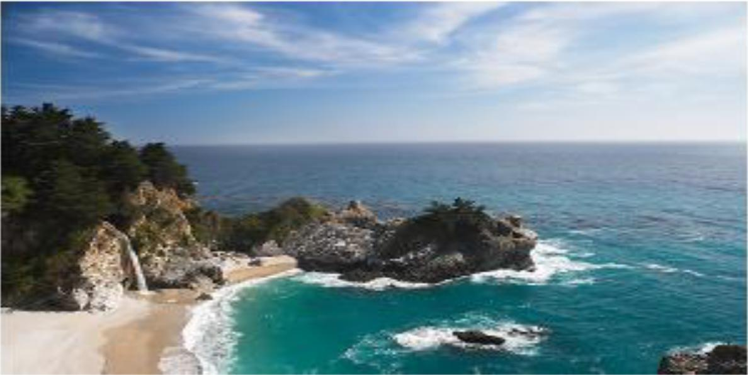

**Figure 6: One horizontal seam removed (597 x 1188)**

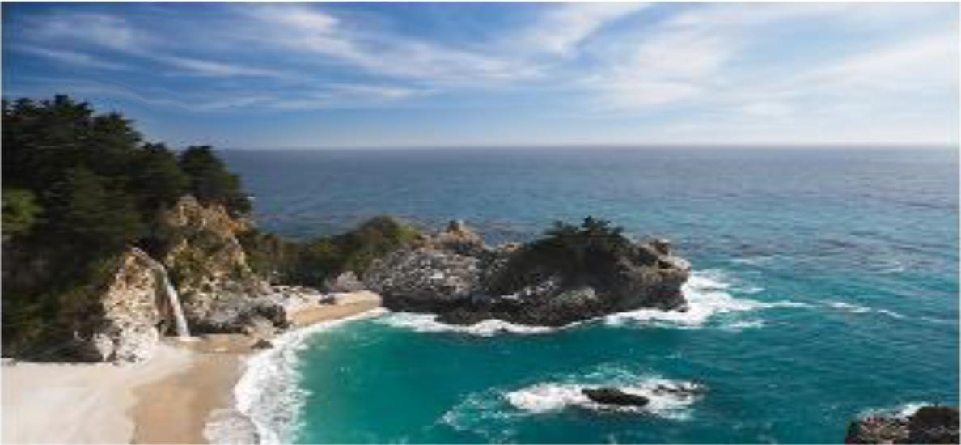

**Figure 7: 48 horizontal seams removed (550 x 1188)**

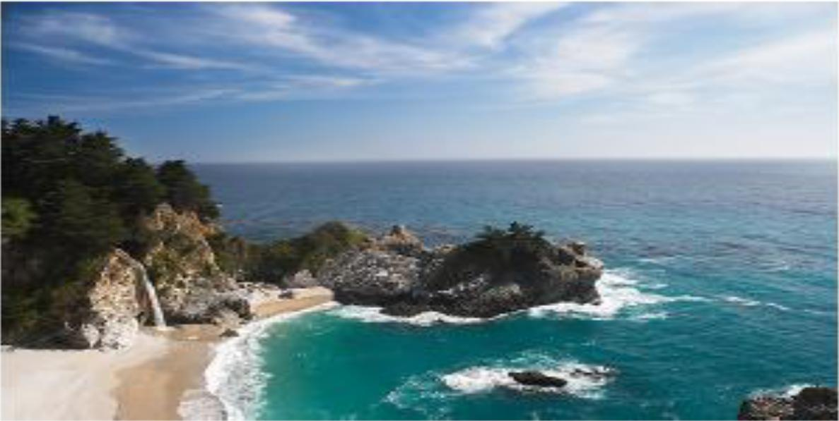

**Figure 8: One vertical seam and one horizontal seam removed (597 x 1187)**

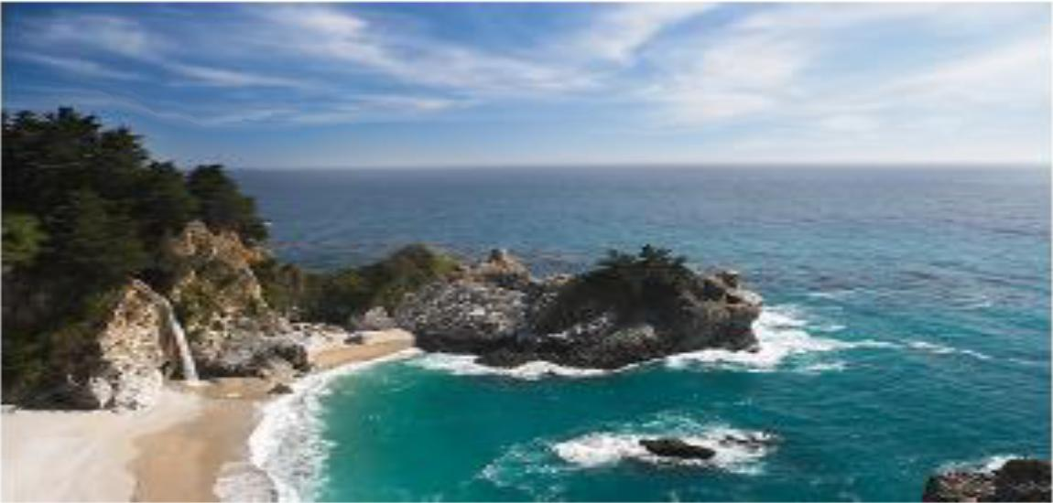

**Figure 9: 38 vertical seams and 48 horizontal seams removed (550 x 1150)**

**Task 2: Gradient Domain Blending**

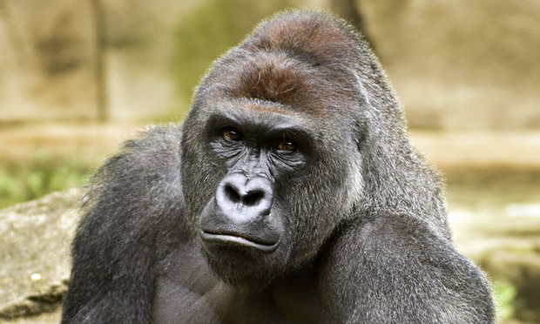

**Figure 1: Source image (Harambe)**

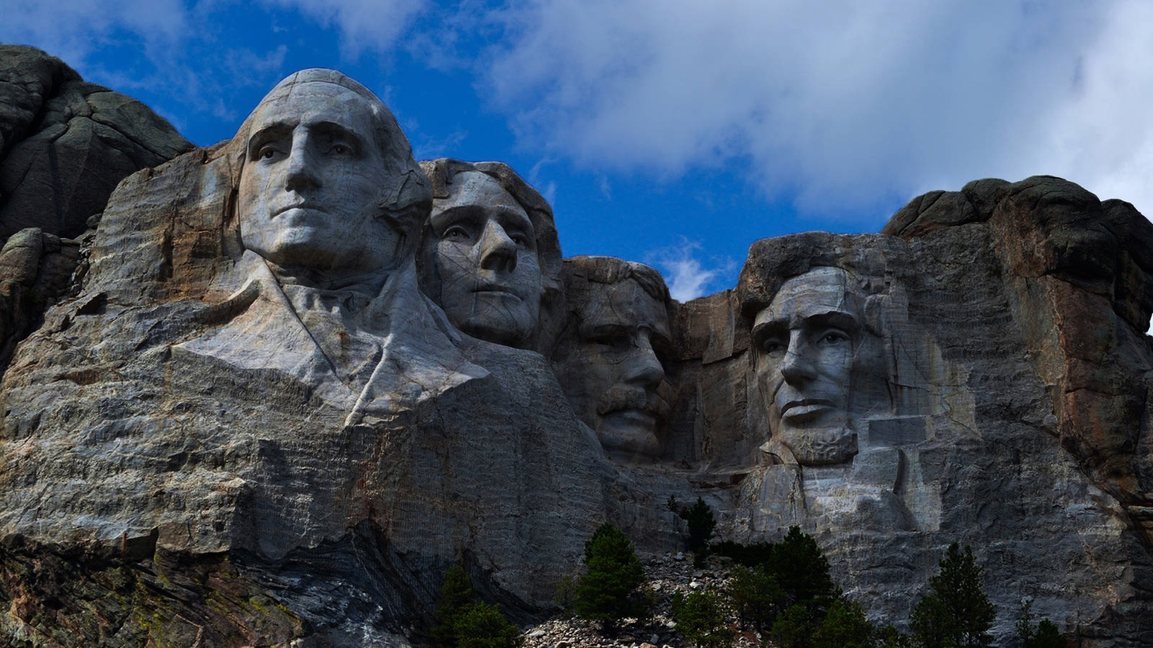

**Figure 2: Target image (Mount Rushmore)**

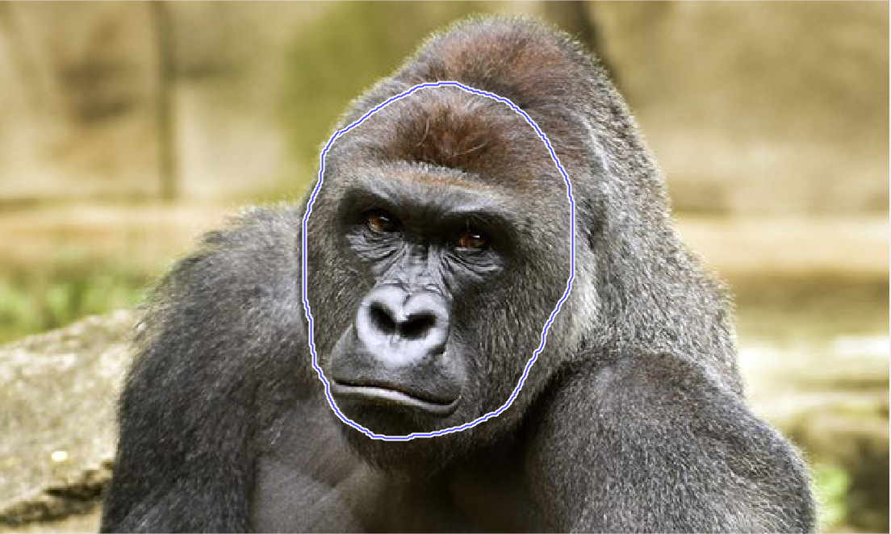

**Figure 3: Mask selection in source image for blending**

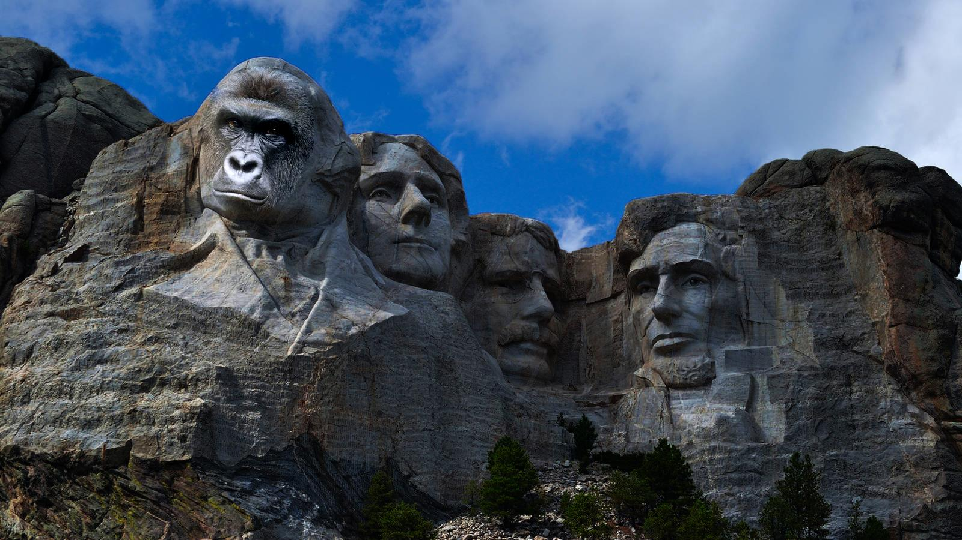

**Figure 4: Final blending image (Harambe For President!)**

**\* Running demo.m will take a couple of minutes, since the images are big.**